ADAPTIVE LEARNING INTELLIGENCE PLATFORM USING EDUCATIONAL DOCUMENT ANALYSIS AND PERSONALIZED LEARNING ANALYTICS
Design and Implementation
Department of Computer Science and Engineering, TKR College of Engineering & Technology
Batch A1 (CSE-A) · Academic year [ACADEMIC YEAR]
Table 1: Project team
S.No. | Student name | Roll number
1 | A Dhanush | 23K91A0501
2 | Ale Vijayalaxmi | 23K91A0508
3 | Burri Mallikarjun | 23K91A0549
4 | Atragada Nagatrimurthulu | 23K91A0517

Project guide: Raghavendra
Chapter and section numbers quoted in the text (for example Chapter 8 or Section 6.2) refer to the full project report, 17.Final Document. Figures and tables in this document are numbered from 1.

1. DESIGN

1.1 Design goals
The design follows from the requirements of Chapter 4: answer from the student's own documents and show where the answer came from; run on one ordinary Windows PC without a graphics processor or a database server; keep each student's documents private; behave the same through the Flask pages and the JSON API; and stay simple enough to test end to end.
• One set of modules, two interfaces. backend/main.py contains no retrieval, quiz or grading logic of its own; it imports db.py, config.py, utils/* and the index cache of app.py, so the two interfaces cannot disagree.
• SQLite and a rebuilt index. The data are small and written by one process, so SQLite gives transactions and cascading deletes with no installation, and the TF-IDF index (263 ms for 672 chunks) is rebuilt after each change instead of stored, so it is never stale.
• Answers only from the notes. The offline answerer selects sentences from the retrieved passages, so it cannot add words that are not in the notes; the optional model is told to use only the context. The correct quiz option stays on the server until grading.

1.2 System architecture
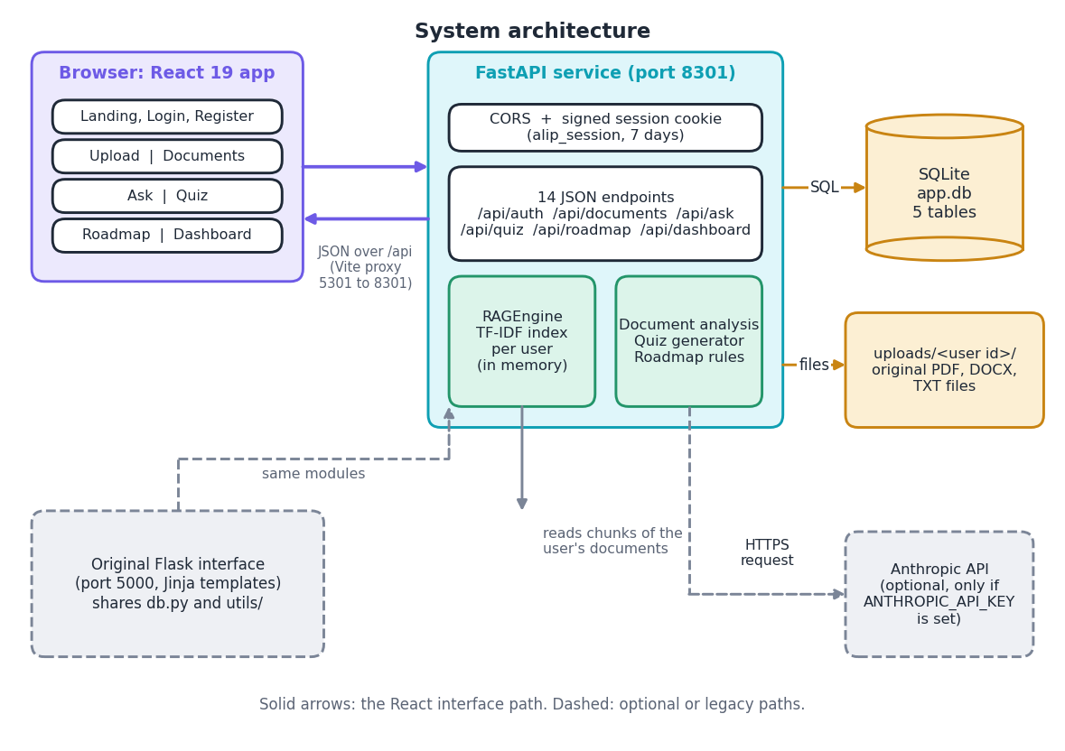
Figure 1: System architecture of the Adaptive Learning Intelligence Platform: browser, FastAPI service, SQLite and the file store.
The browser runs the React application; the FastAPI service on port 8301 applies a CORS rule and a signed session cookie (alip_session, seven days) and exposes 14 JSON endpoints; the stores are instance/app.db and uploads/<user id>/. The Anthropic call and the original Flask interface (port 5000, same db.py and utils/) are optional paths.
The contract between browser and server is narrow: JSON with a session cookie, allowed from localhost:5301 and 127.0.0.1:5301 only. There is no message queue, vector database or background worker; every request is synchronous, which is adequate at the measured median of 29.5 ms for an answer.

1.3 High-level workflow
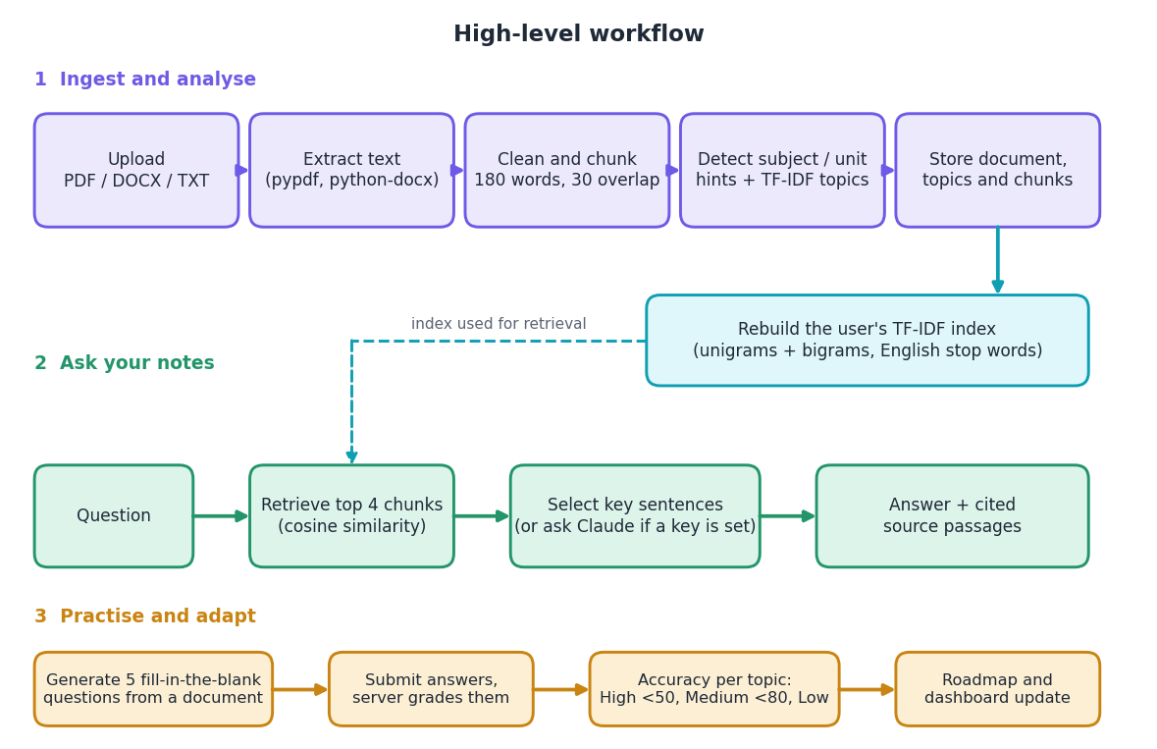
Figure 2: High-level workflow: ingest and analyse, ask, then practise and adapt.
Ingestion (parse, clean, chunk, detect headings, topics, store and re-index), asking (vectorise, retrieve four chunks, select sentences or call the model, show sources) and practice (five cloze questions, server-side grading, accuracy per topic, priority thresholds at 50 and 80 percent).

1.4 Data flow diagrams

1.4.1 Level 0
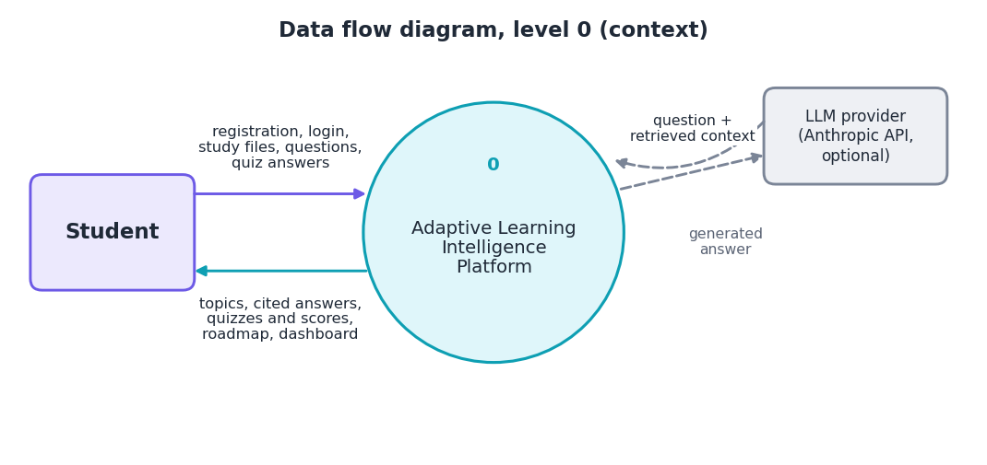
Figure 3: Level 0 data flow diagram (context diagram).
The platform is one process between the student and the optional language-model provider.

1.4.2 Level 1
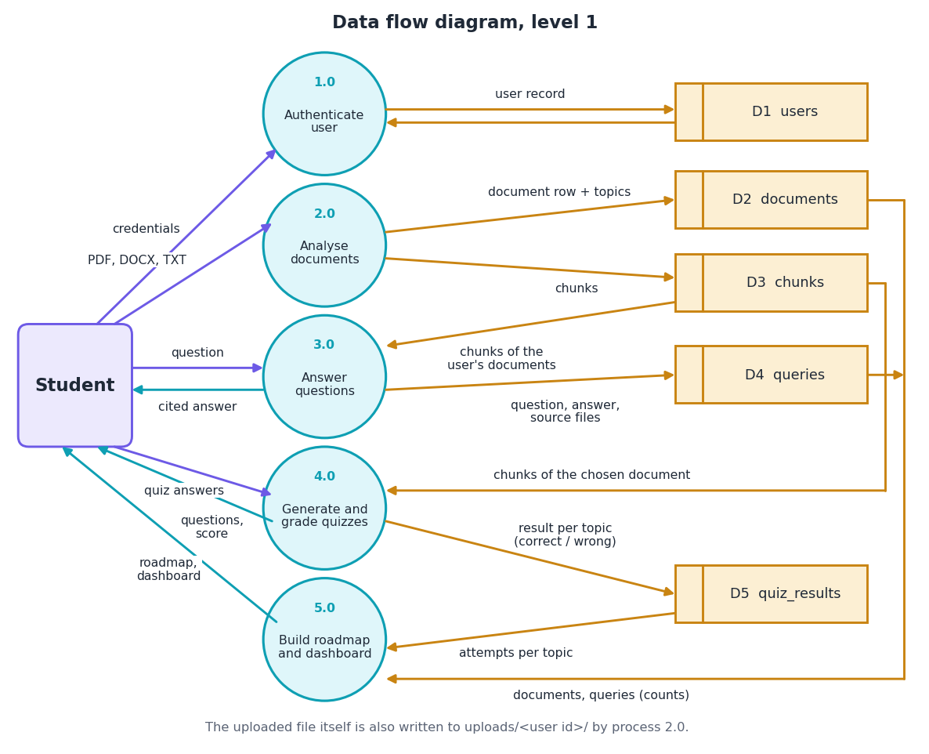
Figure 4: Level 1 data flow diagram with five processes and five data stores.
Five processes (authenticate, analyse documents, answer questions, generate and grade quizzes, build roadmap and dashboard) read and write five stores: users, documents, chunks, queries and quiz_results.

1.4.3 Level 2: document analysis
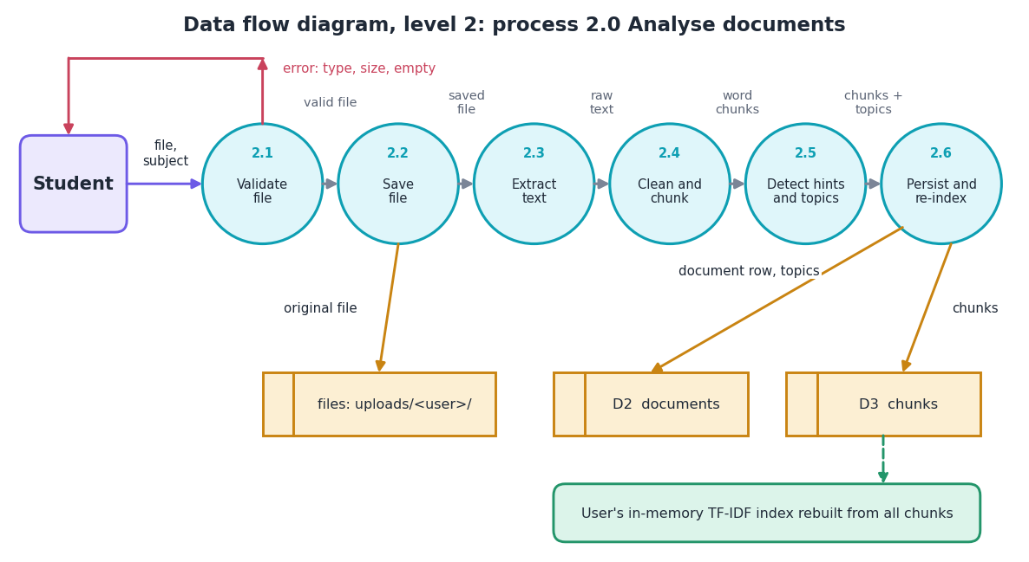
Figure 5: Level 2 data flow diagram of process 2.0, analyse documents.
Process 2.0 validates the file (type, 16 MB, safe name), saves it, extracts text, cleans and chunks it, detects headings and at most twelve topics, then stores rows and rebuilds the user's index.

1.4.4 Level 2: answering questions
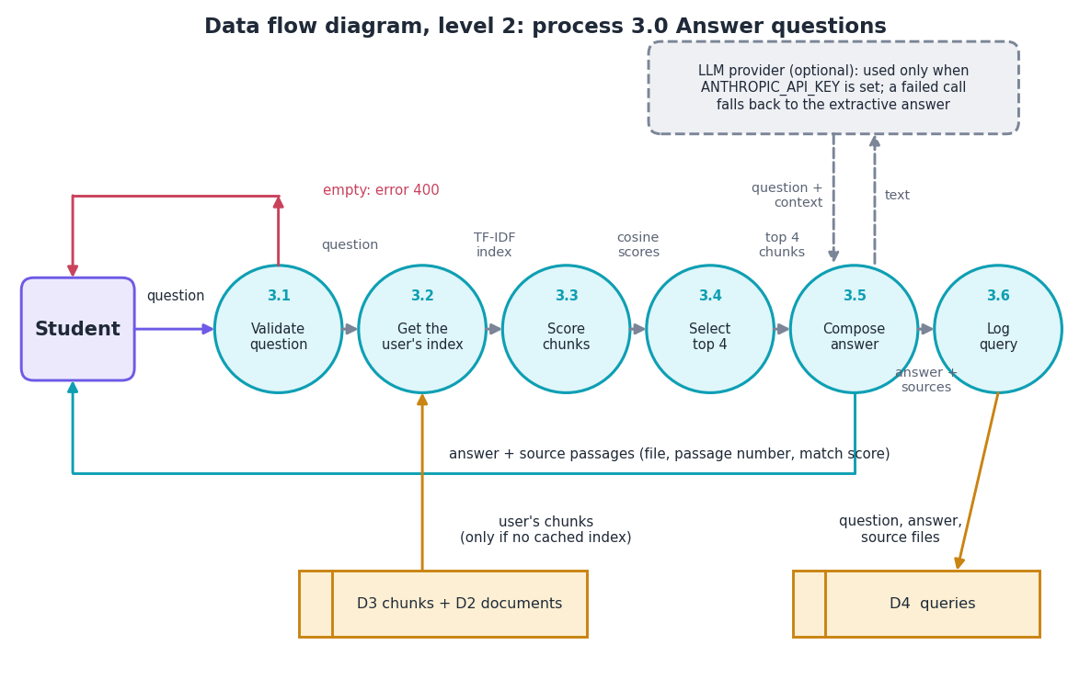
Figure 6: Level 2 data flow diagram of process 3.0, answer questions.
Process 3.0 rejects an empty question, obtains the cached or freshly built index, scores chunks by cosine similarity, keeps the top four with score above zero, composes the answer (extractive, or the optional model with fallback) and logs the query.

1.5 UML diagrams

1.5.1 Class diagram
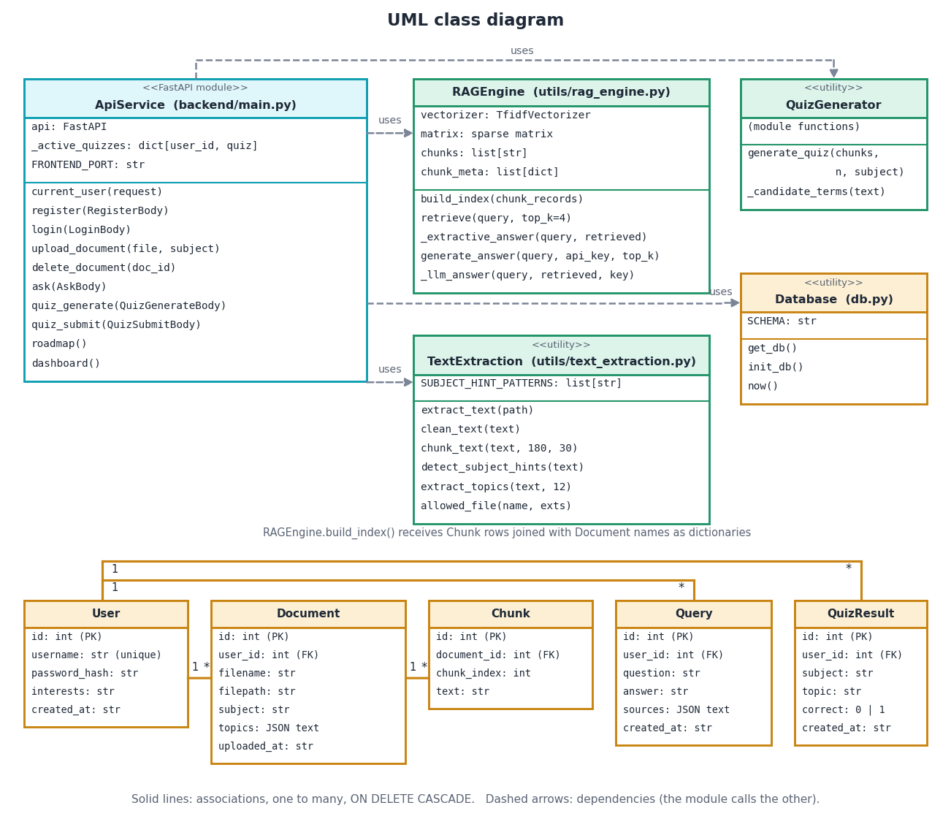
Figure 7: UML class diagram of the service modules and the five entities.
ApiService uses RAGEngine, TextExtraction, QuizGenerator and Database; the five entities hold the same relationships as the ER diagram (a user has many documents, queries and quiz results; a document has many chunks).

1.5.2 Sequence diagrams
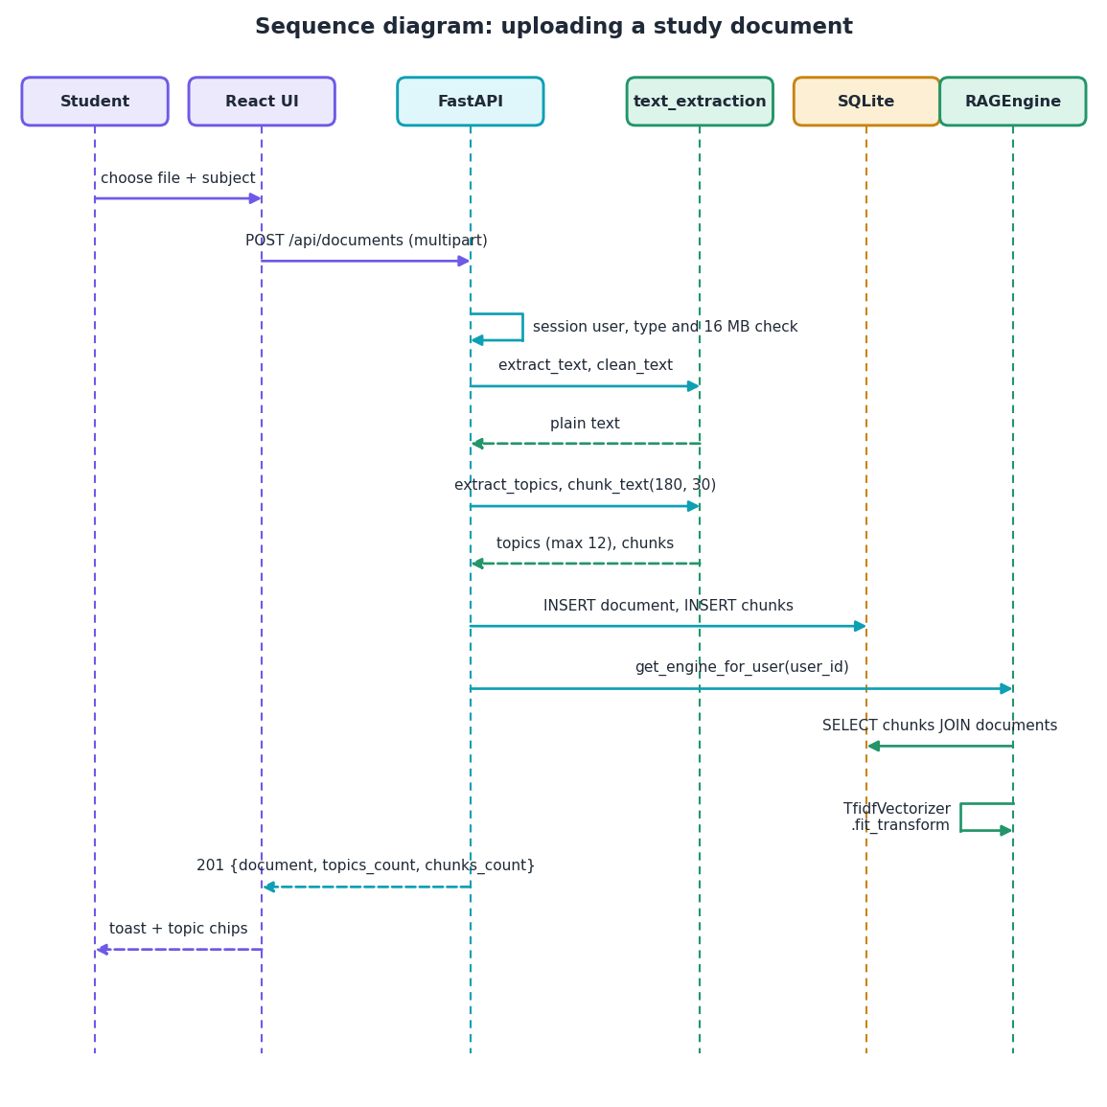
Figure 8: Sequence diagram of uploading a study document.
The upload request passes the session and file checks, the extraction helpers produce text, topics and chunks, SQLite stores them and the user's TF-IDF engine is rebuilt before the 201 response.
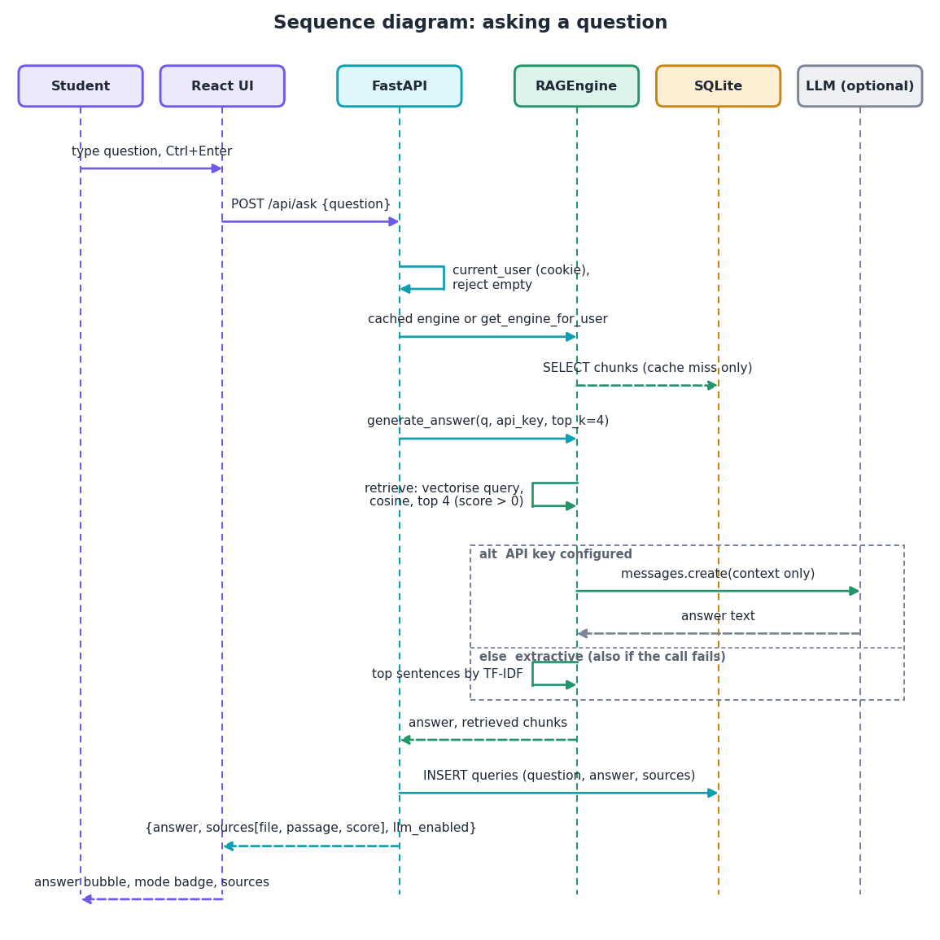
Figure 9: Sequence diagram of asking a question.
The question reaches the cached engine, the four best chunks are retrieved, the answer comes from the model (if a key is configured) or from sentence selection (also on failure), and the result is stored and returned with sources.

1.5.3 Use case diagram
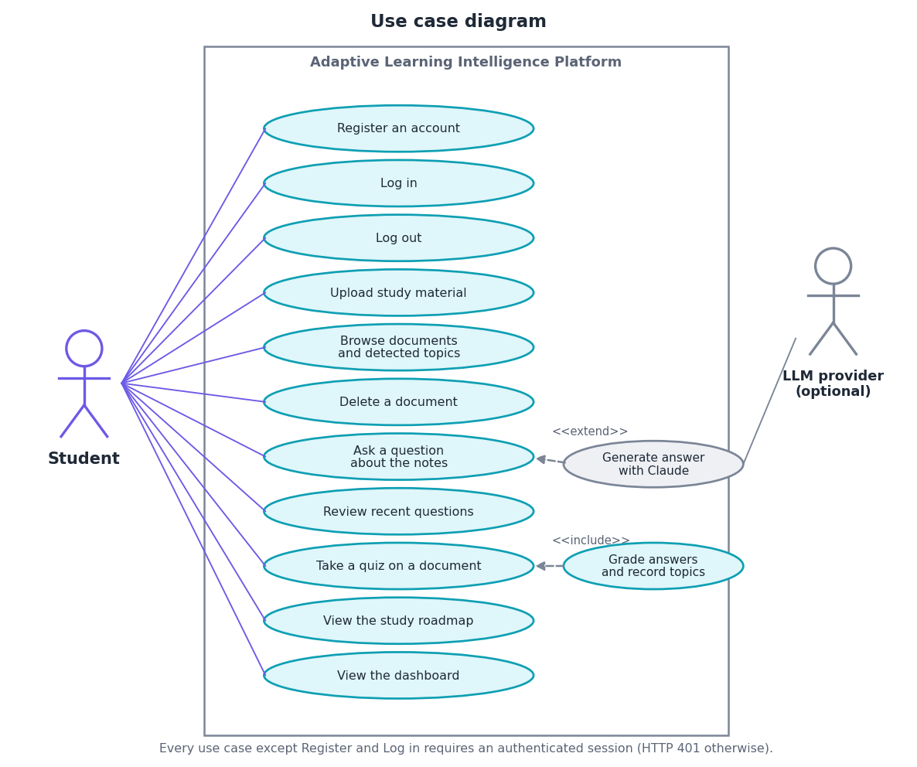
Figure 10: Use case diagram: one actor, eleven use cases and one optional external actor.
The student is the only actor; asking can be extended by the optional model, and taking a quiz includes grading. All use cases except registration and login need a session (HTTP 401 otherwise).

1.6 Database design
The data model has five tables in instance/app.db, created by db.init_db() with CREATE TABLE IF NOT EXISTS. Foreign-key checking is enabled for every connection (PRAGMA foreign_keys = ON) and every foreign key cascades on delete. The table gives the columns as defined in db.py.
Table 2: Tables and columns of the database
Table | Columns | Type and constraint | Meaning
users | id | INTEGER, primary key | Autoincrement identifier
 | username | TEXT, unique, not null | Login name, trimmed
 | password_hash | TEXT, not null | Werkzeug scrypt or PBKDF2 hash, never the password
 | interests, created_at | TEXT | Free text from registration; UTC ISO timestamp
documents | id, user_id | INTEGER, primary key; foreign key | Document identifier; owner (ON DELETE CASCADE)
 | filename, filepath | TEXT, not null | Secured file name; path under uploads/<user id>/
 | subject, topics | TEXT (topics: JSON list) | Subject typed at upload (default 'General'); up to twelve hints and keywords
 | uploaded_at | TEXT, not null | UTC ISO timestamp
chunks | id, document_id | INTEGER, primary key; foreign key | Chunk identifier; parent document (ON DELETE CASCADE)
 | chunk_index, text | INTEGER; TEXT, not null | Passage number shown as the source; about 180 words
queries | id, user_id | INTEGER, primary key; foreign key | Question identifier; asking user
 | question, answer, sources, created_at | TEXT (sources: JSON list) | As typed; answer returned; source file names; UTC ISO timestamp
quiz_results | id, user_id | INTEGER, primary key; foreign key | Result identifier; student
 | subject, topic, correct, created_at | TEXT; TEXT; INTEGER; TEXT | Subject of the document; blanked term used as topic; 1 if correct, 0 if wrong or blank; UTC ISO timestamp

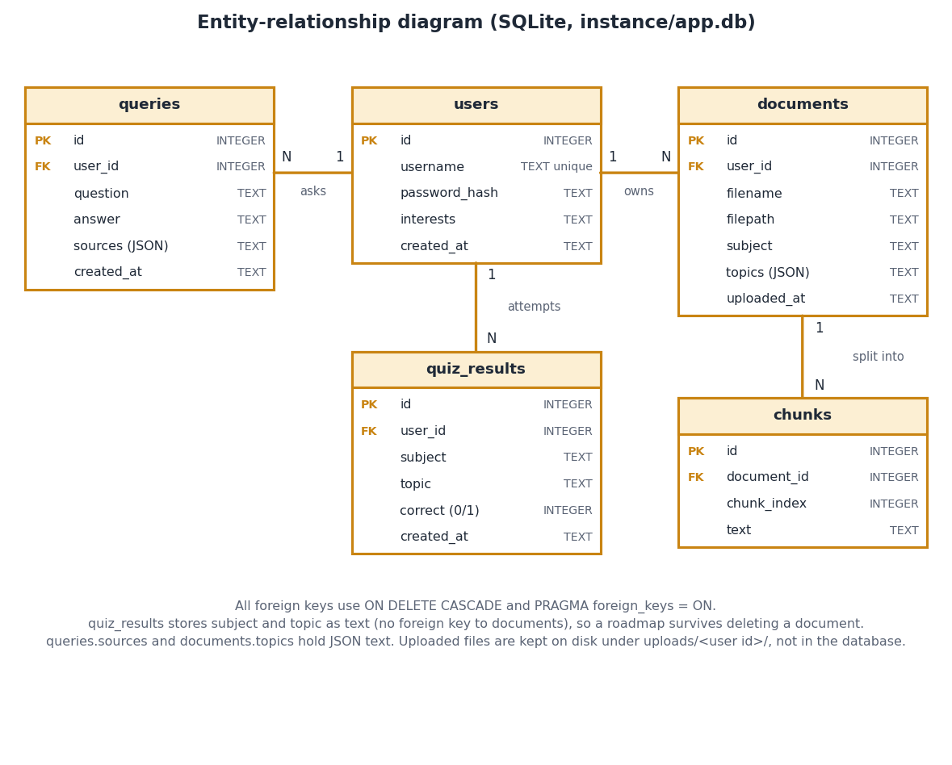
Figure 11: Entity-relationship diagram of the SQLite database.
users parents documents, queries and quiz_results; documents parents chunks; all foreign keys cascade on delete. quiz_results keeps subject and topic as text, so a roadmap survives deleting its document.
Two choices in the schema have consequences. quiz_results records subject and topic as text, so a roadmap survives the deletion of a document, but a topic name such as "data" is shared by every document that yields it and its accuracy mixes attempts from all of them. And the original file is written to uploads/<user id>/<secured name>, so two uploads with the same name share one path: deleting one removes the file of the other while its chunks stay in the database. This is recorded by a test (Chapter 7) and listed among the limitations.

1.7 Module design
The retrieval and quiz logic is small: 331 lines in three files under utils/. The API layer is 430 lines, the original Flask application 402 lines with ten templates, and the React interface 4,867 lines of TypeScript.
Table 3: Module breakdown
Module | Lines | Responsibility | Key names
backend/main.py | 430 | FastAPI application: 14 endpoints, Pydantic bodies, CORS, session middleware, helpers | ask, upload_document, quiz_submit, roadmap
app.py | 402 | Original Flask interface and the per-user index cache _rag_cache, get_engine_for_user | get_engine_for_user
db.py | 74 | SQLite connection, five-table schema, init_db, timestamp helper | get_db, SCHEMA
config.py | 15 | Secret key, database path, upload folder, allowed types, 16 MB limit, optional API key | Config
utils/text_extraction.py | 127 | Extraction for PDF, DOCX, TXT; cleaning; chunking; heading hints; TF-IDF topics | extract_text, chunk_text, extract_topics
utils/rag_engine.py | 120 | TF-IDF index, retrieval, extractive answer, optional Claude call | RAGEngine
utils/quiz_generator.py | 84 | Cloze question generation from TF-IDF terms | generate_quiz
frontend/src | 4,867 | Ten pages, interface kit, theme, motion, charts, API client and auth context | Ask.tsx, api.ts, AppShell.tsx
tests/ | 631 | 84 pytest tests with a temporary database | conftest.py, test_api.py
scripts/ | 2,160 | Corpus builder, questions, experiments, API timing, screenshots, figures, diagrams | run_experiments.py
run.bat | 23 | Creates the virtual environment, installs packages, starts both servers | -

Dependencies run one way: the interfaces call utils/ and db.py; utils/ imports only scikit-learn, pypdf, python-docx and the standard library. RAGEngine receives chunk records as plain dictionaries, so the test suite exercises it without a database (nine tests).

1.8 Algorithm design

1.8.1 Retrieval and answering
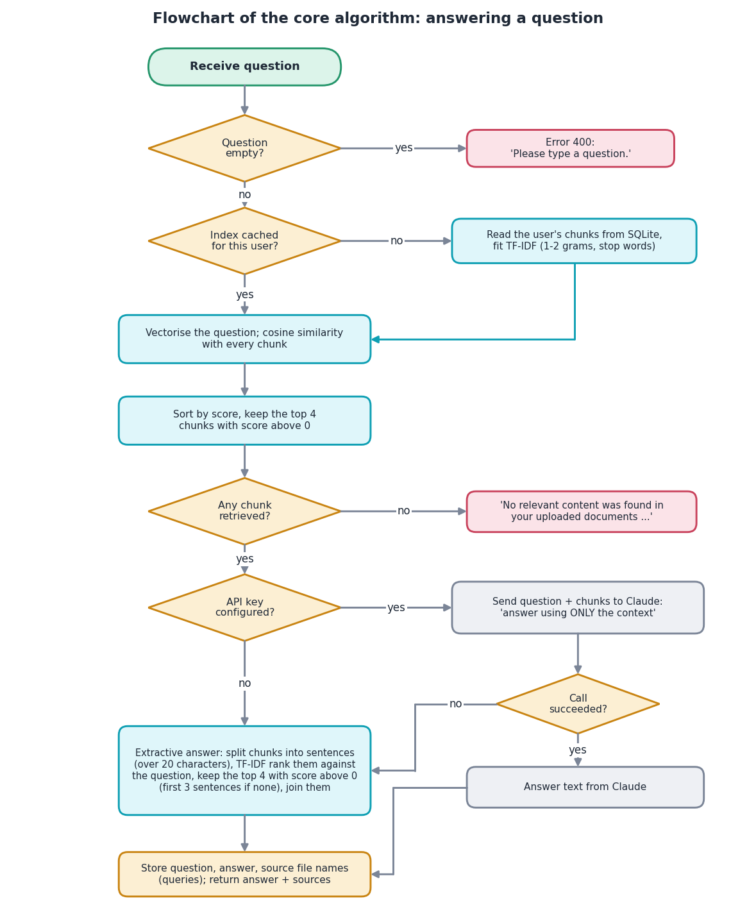
Figure 12: Flowchart of the core algorithm: retrieval and answer generation.
Empty question gives error 400; otherwise the index is taken from the cache or built, four chunks are retrieved, an empty result returns the fixed no-content message, and the answer is produced by the model or by sentence selection.
Retrieval is lexical (TF-IDF with unigrams and bigrams) because it needs no model download, GPU or network and the index rebuilds in a fraction of a second [6], [7]. The cost is quality: the shipped retriever reaches Hit@4 of 0.792, below BM25 (0.833) and a BM25 plus dense hybrid (0.889), the kinds of retriever used by the base paper [1], [5], [9]. The top_k is four so that the context stays near 720 words. The extractive answer guarantees that every word comes from the passages; the price is a loss of answer-key recall from 0.861 in the passages to 0.667 in the answer (Chapter 8). Unlike the base paper, there is no question classifier, sub-question decomposition, reranker or model-based compression [1], [11], [15].

1.8.2 Quiz generation and roadmap
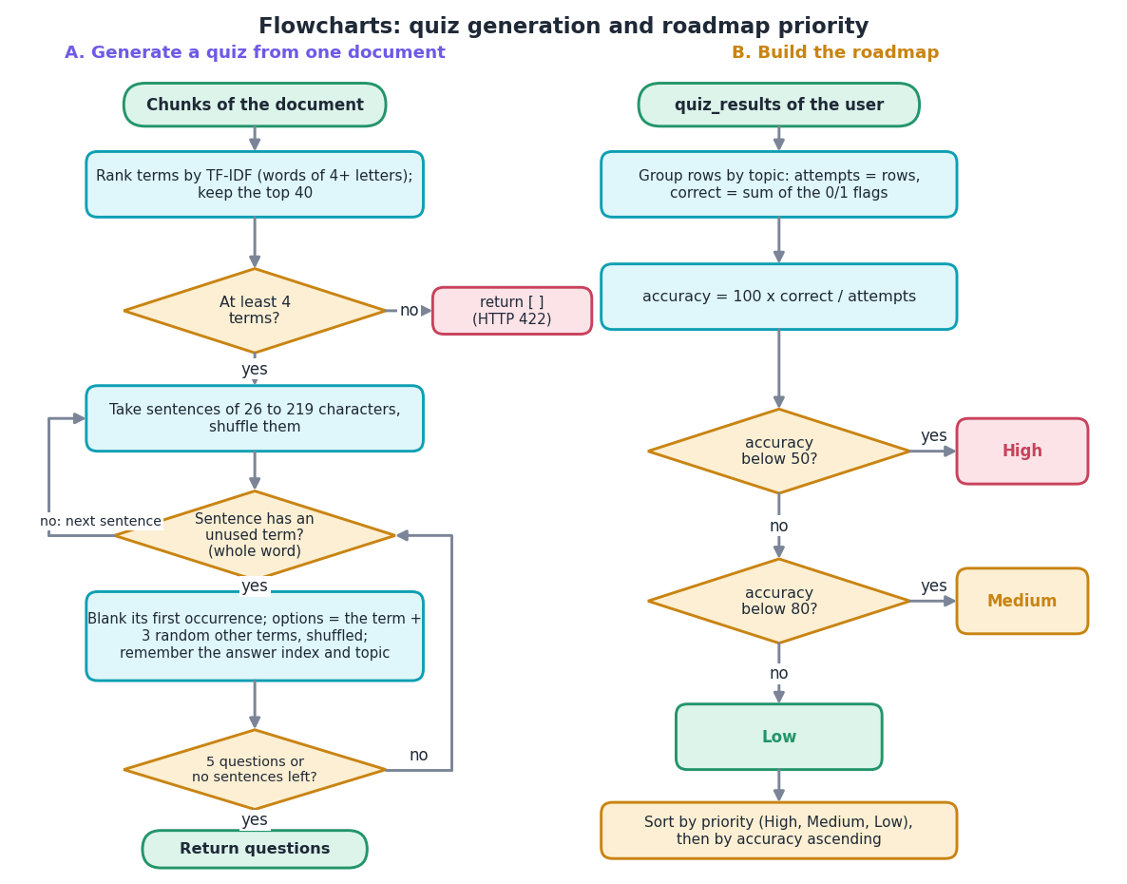
Figure 13: Flowcharts of quiz generation (left) and the roadmap priority rule (right).
Quiz: top 40 TF-IDF terms, shuffled sentences of 26 to 219 characters, first unused whole-word term blanked, three distractors, five questions or until sentences run out. Roadmap: accuracy per topic, High below 50, Medium below 80, otherwise Low.
The quiz generator needs no language model, but only the first occurrence of a blanked term is removed, a distractor may fit the sentence as well, and a sentence may begin in the middle of a thought. The roadmap uses fixed thresholds of 50 and 80 percent on one signal, the share of correct answers per topic: a transparent rule, not a learner model such as knowledge tracing [17] used by tutoring systems [2].

1.9 API design
Request bodies are Pydantic models (RegisterBody, LoginBody, AskBody, QuizGenerateBody, QuizSubmitBody), so a missing or mistyped field is reported with status 422 before any code runs. Every route except health, register, login, logout and me depends on current_user, which answers 401 when the session has no user. Interactive documentation is generated at /api/docs.
Table 4: Endpoints of backend/main.py
Method | Path | Request and response | Errors
GET | /api/health | {status, llm_enabled} | -
POST | /api/auth/register | In: username, password, interests. Out: message (201) | 400 empty, 409 duplicate
POST | /api/auth/login | In: username, password. Out: id, username, interests; sets the session cookie | 401
POST | /api/auth/logout | Clears the session | -
GET | /api/auth/me | Signed-in user, or null with HTTP 200 when nobody is signed in | -
GET | /api/dashboard | doc_count, query_count, quiz_attempts, performance[subject, accuracy, attempts], five latest documents | 401
GET | /api/documents | Documents with topics and chunk_count, newest first | 401
POST | /api/documents | In: multipart document and subject. Out: document, topics_count, chunks_count, warning (201) | 400 type, 413 over 16 MB
DELETE | /api/documents/{id} | Deletes chunks, row and file; refreshes the index | 404
POST | /api/ask | In: question. Out: answer, sources[text, score, doc_name, chunk_index], llm_enabled | 400 empty
GET | /api/ask/history | The last ten questions with answer and source names | 401
POST | /api/quiz/generate | In: doc_id. Out: five questions with options and topic (answers withheld) | 404, 422 too little text
POST | /api/quiz/submit | In: answers (index or null per question). Out: correct, total, score_pct, per-question results | 409 no active quiz
GET | /api/roadmap | Topics with subject, accuracy, attempts, priority, sorted weakest first | 401

Errors use the standard detail field, which the front end turns into a sentence; a network failure produces "Can't reach the server. Check that the backend is running on port 8301". The client sends cookies with every request, and a 401 on a protected page sends the user to the login page and back after sign-in.

1.10 User interface design
The React interface follows the Aurora Glass design kit: translucent glass cards over a soft gradient backdrop, violet and cyan accents, a sidebar that becomes a drawer on small screens, and a light and a dark theme sharing one set of colour tokens (stored under alip-theme, defaulting to the system preference).
Table 5: Pages of the React application
Page | Route | Content
Landing | / | Hero, how it works, example answer, statistics strip, light and dark theme switch
Login, Register | /login, /register | Credential forms with validation messages; registered users are redirected to the app
Dashboard | /app | Counters for documents, questions and quiz questions, subject-wise accuracy chart, recent documents
Upload | /app/upload | File drop area, subject field, processing result with topic chips and a link to a quiz
Documents | /app/documents | Searchable table with subject, topics, chunks, upload time, quiz and delete buttons
Ask your notes | /app/ask | Question box, answer, mode badge, expandable sources with match score, last ten questions
Quiz | /app/quiz | Document picker, five questions with four options, result with per-question review
Study roadmap | /app/roadmap | Counters per priority, filter tabs, sortable table with accuracy bar and attempts

• States and feedback. Every data page has loading, empty and error states, and a 401 redirects to login. Toasts confirm uploads ("12 topics detected, 4 chunks indexed"), quiz submissions and errors; a badge tells whether an answer came from the offline mode or from Claude.
• Charts and layout. Subject accuracy is a bar chart in three colours (below 50, 50 to 79, 80 and above). The layout was captured at 1440, 768 and 360 pixels in both themes with no console error and no horizontal overflow (Chapter 7), and every page is a lazy chunk (the largest, the landing page, is 18.5 kB before compression).
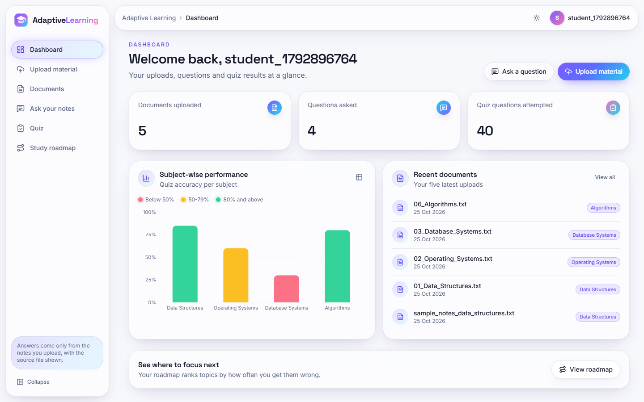  Figure 14: Dashboard with counters, subject accuracy and recent documents. | 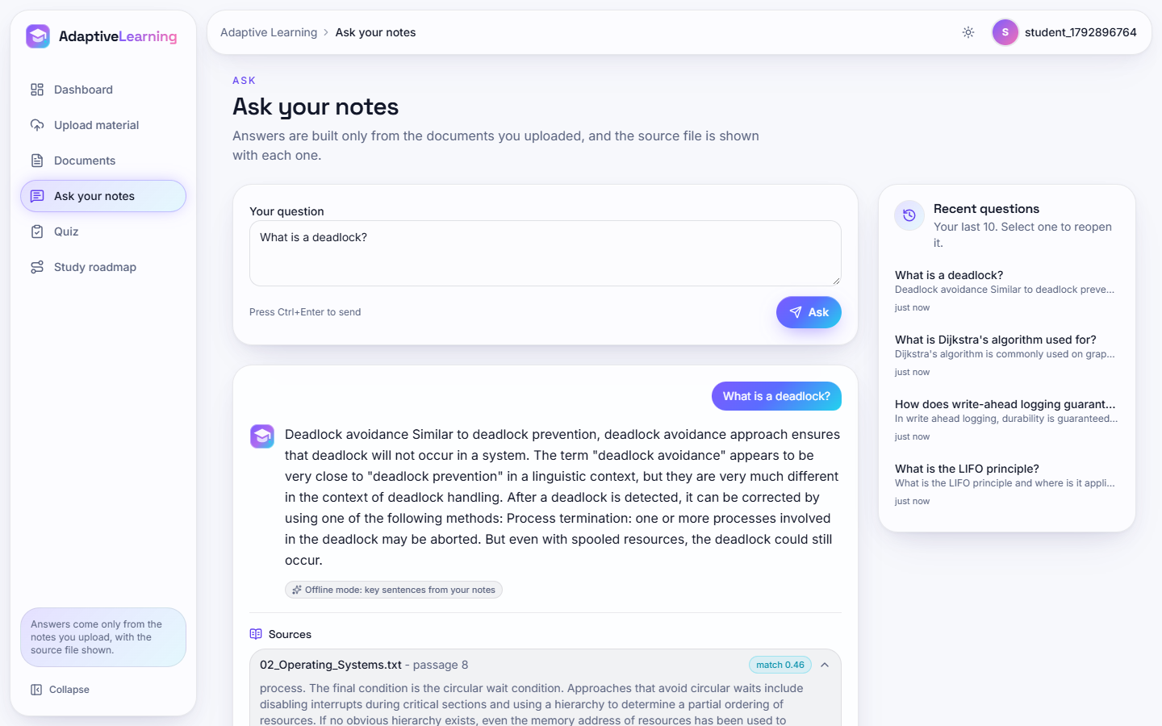  Figure 15: Ask your notes: answer, offline-mode badge and sources.

There is no administrator interface, teacher view, notification or revision calendar; these are listed as future work in Chapter 10.

2. IMPLEMENTATION

2.1 Application architecture
A request travels from a React page, through the Vite development proxy (port 5301 to 8301), to the FastAPI application in backend/main.py. The module does not reimplement the pipeline: it imports db.py, config.py and utils/* and the index cache from the original Flask module app.py (import app as legacy), so both interfaces use identical logic and the same SQLite file. Middleware adds CORS for the two frontend origins and a signed session cookie.
Document upload is the longest path. After validating the extension and size, the handler writes the file, extracts and cleans the text, derives the topics, cuts the chunks, inserts one documents row and one chunks row per window, and calls get_engine_for_user, which reads all of the user's chunks and fits a new TF-IDF model. A question then needs only the cached engine (legacy._rag_cache): it calls generate_answer(question, api_key) and logs the exchange in queries.
Rebuilding the index after each upload keeps the code simple and the index consistent, but its cost grows with the user's total number of chunks: uploading the six corpus files one by one took between 201 and 2501 ms per file in the measured run (Chapter 7). Retrieval itself takes a median of 2.0 ms at 672 chunks and 17.6 ms at 5,376 chunks, so one student's notes are served comfortably; the design is not meant for shared collections of many users in one process.
The quiz endpoints keep the generated questions, including the correct answer index, in a Python dictionary _active_quizzes keyed by user, so that the browser never receives the answers before grading. This state lives in the process: a restart or a second worker loses it, and the next submission then receives HTTP 409. The Flask interface keeps the same data in its cookie session instead.
The roadmap is computed on every request from the quiz_results rows, grouped by topic and compared with the thresholds 50 and 80; nothing is cached.
Grouping is by topic string only, so two subjects that produce the same keyword (for example 'data' in Data Structures and in Database Systems) share one roadmap row, and the subject shown is the one of the latest result.

2.2 API design
The API has fourteen JSON endpoints under /api. Request bodies are Pydantic models (RegisterBody, LoginBody, AskBody, QuizGenerateBody, QuizSubmitBody); the upload is multipart. Errors use FastAPI's {"detail": ...} form, which the React client shows as a message.
Table 6: API endpoints
Method | Path | Purpose | Status codes
GET | /api/health | Status and whether an LLM key is configured | 200
POST | /api/auth/register | Create a user from username, password, interests | 201; 400 empty field; 409 duplicate
POST | /api/auth/login | Check the password hash and set the session cookie | 200; 401
POST | /api/auth/logout | Clear the session | 200
GET | /api/auth/me | Current user, or null when signed out | 200
GET | /api/dashboard | Counts, accuracy per subject, five latest documents | 200; 401
GET | /api/documents | Documents with chunk counts | 200; 401
POST | /api/documents | Upload a file (multipart: document, subject) | 201; 400 type; 413 over 16 MB; 401
DELETE | /api/documents/{id} | Delete document, chunks and file; rebuild the index | 200; 404
POST | /api/ask | Answer a question with sources | 200; 400 empty; 401
GET | /api/ask/history | The ten latest questions | 200; 401
POST | /api/quiz/generate | Five cloze questions from one document (answers withheld) | 200; 404; 422 too little text
POST | /api/quiz/submit | Grade the active quiz and store results | 200; 409 no active quiz
GET | /api/roadmap | Topics with accuracy, attempts and priority | 200; 401

Authentication is a signed cookie (alip_session, seven days, SameSite Lax) set by login; every endpoint except health, register, login, logout and me returns 401 without it, which the test suite checks for nine routes. Passwords are hashed with Werkzeug before storage. The sample screens of Chapter 8 show the API in use.

2.3 Security and error handling
Security was tested as a feature (Chapter 7). The table lists the situations that are handled.
Table 7: Input validation and errors
Situation | Behaviour | HTTP
Empty username or password at registration | Rejected with a message | 400
Wrong password or unknown user | Same message for both, so existence of a user is not revealed | 401
Protected route without a valid session (including a tampered cookie) | Rejected; the cookie signature is checked | 401
Extension other than pdf, docx, txt (including notes.txt.exe) | Rejected before anything is stored | 400
Filename with path parts (../../evil.txt) or only dots | secure_filename keeps the file inside the user's folder; a name that reduces to nothing is rejected | 201 / 400
Corrupt PDF or file without text | No exception; zero chunks and a warning in the response | 201
Another user's document id (delete, quiz) | Reported as not found; documents and sources of one user never appear for another | 404
SQL-injection text in names or questions | Parameterised queries; the text is stored literally | 200 / 401
Foreign browser origin | No CORS header is returned | -

The posture is that of a local teaching prototype. The session cookie is not marked Secure and the server is plain HTTP, so credentials travel unencrypted without a TLS proxy; there is no rate limiting, account lock-out, password-strength rule or CSRF token (SameSite Lax is the only mitigation); the signing secret defaults to a development value if SECRET_KEY is not set; and the upload body is read fully into memory before the size check. Two uploads of the same file name by one user share one path on disk, so deleting one removes the file the other still lists (its chunks remain, so questions are unaffected); this is a recorded limitation with a test that asserts the current behaviour.
The optional LLM branch falls back silently to the extractive answer on any exception; only the badge in the answer card tells the student which mode produced the answer.

2.4 Installation and execution
Table 8: Software environment used for this work
Component | Version
Operating system / hardware | Windows 11 Pro; Intel Core i5-12500 (6 cores, 12 threads); 15.7 GB RAM; none (CPU only)
Python and packages | Python 3.11.9; scikit-learn 1.5.1; numpy 1.26.4; pypdf 4.3.1; python-docx 1.1.2
Back end | FastAPI 0.115.0; uvicorn 0.30.6; Flask 3.0.3 (original interface); SQLite (Python standard library)
Front end | Node 24.19.0; React 19; Vite 8.3; Tailwind CSS 4; TanStack Query, axios, Recharts, framer-motion, GSAP

One-command start. Python 3.11 or newer and Node.js 20 or newer are required. Running run.bat in 8.ProjectCode (i) creates the virtual environment venv and installs backend/requirements.txt on the first run, (ii) runs npm install in frontend/ if node_modules is missing, and (iii) opens two windows, one for uvicorn backend.main:app --host 127.0.0.1 --port 8301 and one for npm run dev (Vite on 5301). The SQLite database instance/app.db is created on first use; no model has to be trained because the index is built from the user's own uploads. Ports and the cookie-signing secret are read from .env (copied from .env.example); setting ANTHROPIC_API_KEY there, and installing the anthropic package, enables Claude-written answers.
python -m venv venv
venv\Scripts\python -m pip install -r backend\requirements.txt
venv\Scripts\python -m uvicorn backend.main:app --port 8301 # API, docs at /api/docs
cd frontend && npm install && npm run dev # http://localhost:5301
venv\Scripts\python app.py # original Flask UI, port 5000

Checks: python -m pytest -q (84 tests) and python scripts/smoke_test.py (24 checks). scripts/capture_screens.py --rich --responsive records the screens with Playwright; scripts/fetch_corpus.py, run_experiments.py and measure_api.py reproduce the experiments, and serve_scratch.py runs the backend on a throw-away database. A demonstration account (demo, password Demo@1234) exists in the project's own database.

3. KEY CODE WALK-THROUGHS

3.1 Chunking: `chunk_text`
The notes are split into overlapping windows of words. The window of 180 words is long enough to hold a definition together with its example and short enough that four of them (about 720 words) fit in a prompt; the overlap of 30 words keeps a sentence that crosses a boundary whole in at least one chunk. With this setting every one of the 72 evidence fragments of the evaluation lies inside at least one chunk, whereas windows of 60 words cut two of them.
def chunk_text(text, chunk_size=180, overlap=30):
"""Split text into overlapping word-based chunks for retrieval."""
words = text.split()
if not words:
return []
chunks = []
start = 0
while start < len(words):
end = start + chunk_size
chunk = " ".join(words[start:end])
if chunk.strip():
chunks.append(chunk.strip())
if end >= len(words):
break
start = end - overlap
return chunks

3.2 Index and retrieval: `RAGEngine`
The engine fits a TF-IDF vectoriser with unigrams and bigrams and English stop words on the chunks of one user, and scores a query by cosine similarity with every chunk. Chunks with a score of zero are dropped, which is the only form of abstention. The matrix is sparse, so the cost of a query grows linearly with the number of chunks (2.5 ms at 672 chunks, 19.4 ms at 5,376).
def build_index(self, chunk_records):
"""
chunk_records: list of dicts with keys 'text', 'doc_id', 'doc_name', 'chunk_index'
"""
self.chunks = [c["text"] for c in chunk_records]
self.chunk_meta = chunk_records
if not self.chunks:
self.vectorizer = None
self.matrix = None
return
self.vectorizer = TfidfVectorizer(stop_words="english", ngram_range=(1, 2))
self.matrix = self.vectorizer.fit_transform(self.chunks)

def retrieve(self, query, top_k=4):
if not self.chunks or self.vectorizer is None:
return []
query_vec = self.vectorizer.transform([query])
sims = cosine_similarity(query_vec, self.matrix).flatten()
top_indices = np.argsort(sims)[::-1][:top_k]
results = []
for idx in top_indices:
if sims[idx] <= 0:
continue
meta = self.chunk_meta[idx]
results.append({
"text": self.chunks[idx],
"score": float(sims[idx]),
"doc_id": meta.get("doc_id"),
"doc_name": meta.get("doc_name"),
"chunk_index": meta.get("chunk_index"),
})
return results

3.3 The extractive answer
When no language-model key is configured the answer is made of the sentences of the retrieved chunks that are closest to the question. The sentences are re-vectorised together with the question, ranked by cosine similarity and the best four with a positive score are joined. The result contains only words of the notes, which is why answers are grounded by construction; it also explains why the answer is always about 90 words and why a sentence that repeats the question's words can outrank the defining sentence.
def _extractive_answer(self, query, retrieved):
"""Pick the sentences most relevant to the query from retrieved chunks."""
if not retrieved:
return "No relevant content was found in your uploaded documents for this question. Try uploading related notes first."

sentences = []
for r in retrieved:
for s in re.split(r"(?<=[.!?])\s+", r["text"]):
s = s.strip()
if len(s) > 20:
sentences.append((s, r["doc_name"]))

if not sentences:
return retrieved[0]["text"][:500]

vectorizer = TfidfVectorizer(stop_words="english")
try:
all_texts = [query] + [s for s, _ in sentences]
mat = vectorizer.fit_transform(all_texts)
sims = cosine_similarity(mat[0:1], mat[1:]).flatten()
ranked = sorted(zip(sentences, sims), key=lambda x: x[1], reverse=True)
top_sents = [s for (s, _doc), score in ranked[:4] if score > 0]
except ValueError:
top_sents = [s for s, _ in sentences[:3]]

if not top_sents:
top_sents = [s for s, _ in sentences[:3]]

answer = " ".join(top_sents)
return answer

def generate_answer(self, query, api_key=None, top_k=4):
retrieved = self.retrieve(query, top_k=top_k)

if api_key:
try:
answer = self._llm_answer(query, retrieved, api_key)
return answer, retrieved
except Exception:
# Silently fall back to extractive mode if the API call fails
pass

return self._extractive_answer(query, retrieved), retrieved

3.4 The ask endpoint
The endpoint checks the session, rejects an empty question, reuses the cached engine of the user or builds one from the database, asks it for an answer and stores the question, the answer and the source file names. The sources returned to the browser carry the chunk text, the file name, the passage index and the score.
@api.post("/api/ask")
def ask(body: AskBody, user=Depends(current_user)):
question = body.question.strip()
if not question:
raise HTTPException(status_code=400, detail="Please type a question.")
engine = legacy._rag_cache.get(user["id"]) or legacy.get_engine_for_user(user["id"])
answer, sources = engine.generate_answer(question, api_key=Config.ANTHROPIC_API_KEY or None)

conn = get_db()
cur = conn.execute(
"INSERT INTO queries (user_id, question, answer, sources, created_at) VALUES (?, ?, ?, ?, ?)",
(user["id"], question, answer, json.dumps([s["doc_name"] for s in sources]), now()),
)
conn.commit()
created = conn.execute("SELECT created_at FROM queries WHERE id=?", (cur.lastrowid,)).fetchone()
conn.close()
return {
"id": cur.lastrowid,
"question": question,
"answer": answer,
"sources": sources,
"created_at": created["created_at"],
"llm_enabled": bool(Config.ANTHROPIC_API_KEY),
}

3.5 Quiz generation
The top 40 TF-IDF terms of the whole document are the candidate answers. Shuffled sentences of 26 to 219 characters are scanned, and the first term that occurs in a sentence as a whole word and has not been used becomes the blank. Three other terms are the distractors. Because the terms come from the document itself the quiz needs no external resource, but the sentence is not checked for self-containment, which explains the poor questions in the review.
def generate_quiz(chunks, num_questions=5, subject="General"):
"""
chunks: list of raw text chunks (strings) from one or more documents.
Returns a list of question dicts:
{question, options: [...], answer_index, topic}
"""
full_text = " ".join(chunks)
terms = _candidate_terms(full_text, top_n=40)
if len(terms) < 4:
return []

sentences = []
for chunk in chunks:
for s in re.split(r"(?<=[.!?])\s+", chunk):
s = s.strip()
if 25 < len(s) < 220:
sentences.append(s)

random.shuffle(sentences)
questions = []
used_terms = set()

for sentence in sentences:
if len(questions) >= num_questions:
break
lower_sentence = sentence.lower()
found_term = None
for term in terms:
if term in used_terms:
continue
# match whole word/phrase, case-insensitive
pattern = r"\b" + re.escape(term) + r"\b"
if re.search(pattern, lower_sentence):
found_term = term
break
if not found_term:
continue

used_terms.add(found_term)
pattern = re.compile(re.escape(found_term), re.IGNORECASE)
blanked = pattern.sub("_____", sentence, count=1)

distractors = [t for t in terms if t != found_term]
random.shuffle(distractors)
options = [found_term] + distractors[:3]
while len(options) < 4:
options.append("none of the above")
random.shuffle(options)
answer_index = options.index(found_term)

questions.append({
"question": f"Fill in the blank: {blanked}",
"options": options,
"answer_index": answer_index,
"topic": found_term,
"subject": subject,
})

return questions

3.6 The roadmap
Quiz results are stored one row per question with the topic (the blanked term) and a 0 or 1. The roadmap groups the rows by topic, computes accuracy and maps it to a priority. The rule is deliberately simple and explainable: below 50 % is High, below 80 % is Medium. It is keyed by topic only, so the same keyword in two subjects shares one entry.
@api.get("/api/roadmap")
def roadmap(user=Depends(current_user)):
conn = get_db()
rows = conn.execute(
"SELECT subject, topic, correct FROM quiz_results WHERE user_id=?", (user["id"],)
).fetchall()
conn.close()

topic_stats = defaultdict(lambda: {"correct": 0, "total": 0, "subject": "General"})
for r in rows:
stats = topic_stats[r["topic"]]
stats["total"] += 1
stats["correct"] += r["correct"]
stats["subject"] = r["subject"]

items = []
for topic, stats in topic_stats.items():
accuracy = 100 * stats["correct"] / stats["total"]
priority = "High" if accuracy < 50 else "Medium" if accuracy < 80 else "Low"
items.append(
{
"topic": topic,
"subject": stats["subject"],
"accuracy": round(accuracy, 1),
"attempts": stats["total"],
"priority": priority,
}
)
order = {"High": 0, "Medium": 1, "Low": 2}
items.sort(key=lambda x: (order[x["priority"]], x["accuracy"]))
return items

4. IMPLEMENTATION DECISIONS AND THEIR REASONS
The table lists the main implementation decisions, the alternatives that were considered, the reason and what the evaluation later showed.
Table 9: Implementation decisions
Decision | Alternative | Reason | What the measurements showed
TF-IDF with cosine similarity for retrieval | Dense embeddings, BM25 | No model download, no GPU, runs offline in seconds, easy to explain in a viva | Adequate (Hit@4 0.792) but BM25 and BM25 + dense are better (0.833, 0.889)
Word-window chunks of 180 words, 30 overlap | Sentences, paragraphs, 60 to 450 words | Keeps definitions with examples; fits four chunks into a context | Keeps all 72 evidence fragments intact; larger chunks score higher but pass on more words
Extractive answer by default, Claude optional | A language model only | Zero cost and no network; no hallucination in the default mode | 100 % of answer words come from the notes; key recall falls by 19 points against the chunks
Top four chunks | More chunks | Balance between coverage and length | Hit@3 0.736, Hit@4 0.792, Hit@10 0.931
SQLite and files on disk | Server database | Zero set-up for a student project | Median endpoint latency 4 to 30 ms; rare commit stalls of 1 to 2 s
Per-user in-memory index, rebuilt after each change | Persistent or incremental index | Simple and always consistent | Rebuild 197 ms at 672 chunks, 964 ms at 5,376
Quiz answers kept on the server until grading | Send answers to the browser | Prevents reading the answers from the network tab | Tested: generate responses contain no answer index
Cloze questions from TF-IDF terms | Language-model generated questions | Offline and deterministic in structure | 17 of 30 acceptable; needs quality filters
Roadmap thresholds 50 and 80 | Learned model | Transparent rule that a student can read | Boundary behaviour tested; topics too coarse
FastAPI layer over the existing modules, React interface | Rewrite the logic | No retrieval, quiz or grading code duplicated; the Flask interface still works | The same 84 tests cover the shared code
Signed session cookie, Werkzeug password hashing | Tokens in local storage | Simple, HttpOnly, no password in clear text | Hashes verified by test; cookie not Secure (local use)
Scripts that measure everything | One-off manual checks | Numbers in the report are regenerated by commands | Results in experiments/*.json feed the documents

